Name _______________________________ Date ___________________ Period __________

Passive Transport

MAIN IDEA: Diffusion and osmosis are types of passive transport.

1. What is a concentration gradient?

__________________________________________________________________________________

__________________________________________________________________________________

2. What does it mean for a molecule to diffuse down a concentration gradient?

__________________________________________________________________________________

__________________________________________________________________________________

3. Complete the concept map below about passive transport using the following words or phrases:
osmosis, energy, facilitated diffusion, the movement of molecules from high to low concentration, diffusion

Passive Transport requires no

example example

is type of diffusion is
the diffusion
of water

4. How does facilitated diffusion differ from simple diffusion?

__________________________________________________________________________________

__________________________________________________________________________________

5. What will happen to a houseplant if you water it with salt water (a hypertonic solution)?

__________________________________________________________________________________

__________________________________________________________________________________

Name _______________________________ Date ___________________ Period __________

Active Transport

1. How is active transport different than simple diffusion and facilitated diffusion?

__________________________________________________________________________________

2. The prefix exo- means “out of” and the prefix endo- means “taking in”. How do these meanings relate to the meaning of exocytosis and endocytosis?

__________________________________________________________________________________

__________________________________________________________________________________

3.
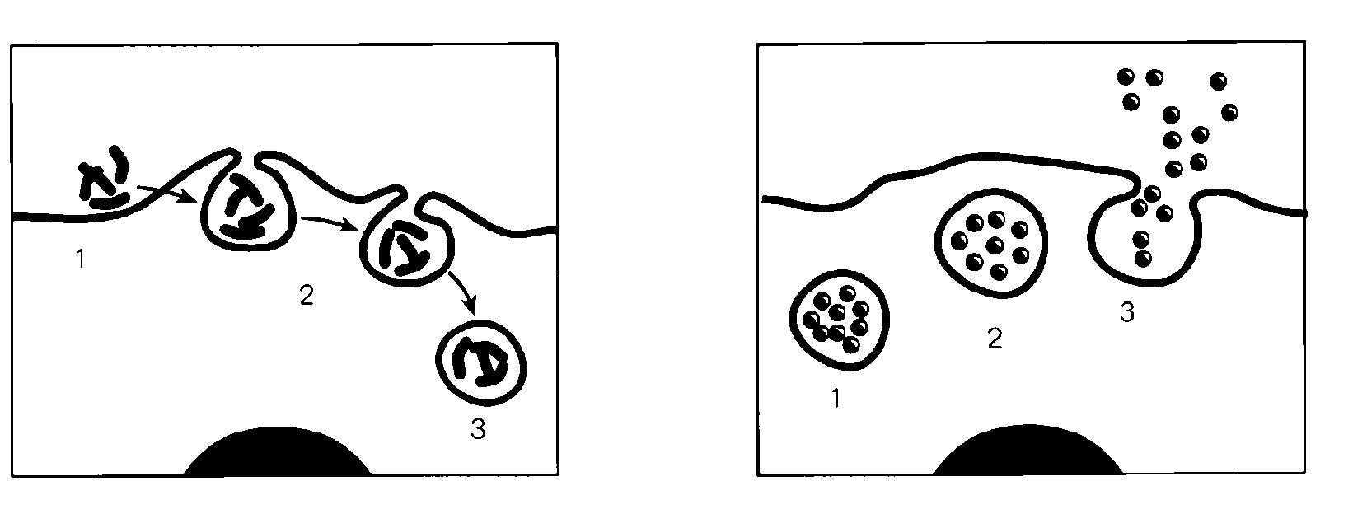
A B

What process is shown in Figure A? _____________________________

What process is shown in Figure B? _____________________________

4. Do you think that endocytosis and exocytosis can occur within the same cell? Explain your reasoning.

__________________________________________________________________________________

__________________________________________________________________________________

5. Predict: If the transport proteins that carry amino acids into a cell stopped working, how might the process affect the cell?

__________________________________________________________________________________

__________________________________________________________________________________

6. Infer: What might you conclude about the membrane structure of the final vesicle formed during exocytosis and the cell membrane?

__________________________________________________________________________________

__________________________________________________________________________________

